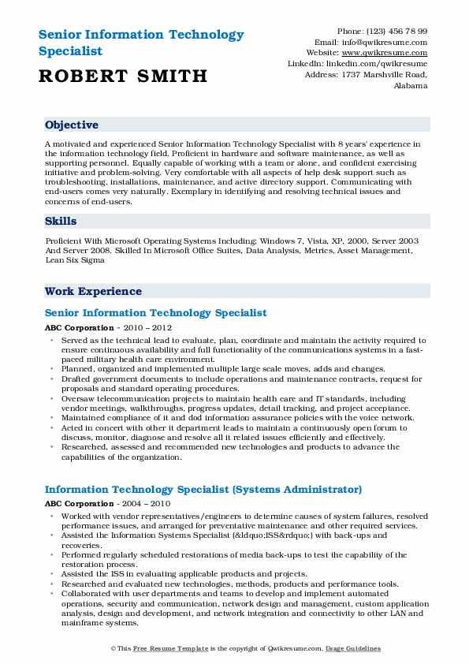
Senior Information Technology Specialist
ROBERT SMITH
Phone: (123) 456 78 99 Email: info@qwikresume.com Website: www.qwikresume.com LinkedIn: linkedin.com/qwikresume Address: 1737 Marshville Road, Alabama
Objective
A motivated and experienced Senior Information Technology Specialist with 8 years' experience in the information technology field. Proficient in hardware and software maintenance, as well as supporting personnel. Equally capable of working with a team or alone, and confident exercising initiative and problem-solving. Very comfortable with all aspects of help desk support such as troubleshooting, Installations, maintenance, and active directory support. Communicating with end-users comes very naturally. Exemplary in identifying and resolving technical issues and concerns of end-users.
Skills
Proficient With Microsoft Operating Systems Including: Windows 7, Vista, XP. 2000, Server 2003 And Server 2008, Skilled In Microsoft Office Suites, Data Analysis, Metrics, Asset Management, Lean Six Sigma
Work Experience
Senior Information Technology Specialist
ABC Corporation - 2010-2012
• Served as the technical lead to evaluate, plan, coordinate and maintain the activity required to ensure continuous availability and full functionality of the communications systems in a fast- paced military health care environment.
⚫ Planned, organized and implemented multiple large scale moves, adds and changes.
⚫ Drafted government documents to include operations and maintenance contracts, request for proposals and standard operating procedures.
"
• Oversaw telecommunication projects to maintain health care and IT standards, including vendor meetings, walkthroughs, progress updates, detail tracking, and project acceptance. Maintained compliance of it and dod information assurance policies with the voice network. Acted in concert with other it department leads to maintain a continuously open forum to discuss, monitor, diagnose and resolve all it related issues efficiently and effectively. ⚫ Researched, assessed and recommended new technologies and products to advance the capabilities of the organization.
Information Technology Specialist (Systems Administrator)
ABC Corporation - 2004 - 2010
•Worked with vendor representatives/engineers to determine causes of system failures, resolved performance issues, and arranged for preventative maintenance and other required services. • Assisted the Information Systems Specialist (&ldquo;ISS&rdquo;) with back-ups and recoveries.
•Performed regularly scheduled restorations of media back-ups to test the capability of the restoration process.
• Assisted the ISS in evaluating applicable products and projects.
⚫Researched and evaluated new technologies, methods, products and performance tools. Collaborated with user departments and teams to develop and implement automated
operations, security and communication, network design and management, custom application analysis, design and development, and network integration and connectivity to other LAN and mainframe systems,
©This Free Resume Template is the copyright of Qwikresume.com. Usage Guidelines

